Name
10th Magnitude [Company address]
Organizational Discovery
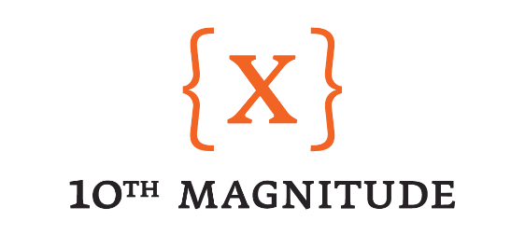

Organizational Discovery - Overview

Description

The goal of organization discovery is to understand the structure and layout from a business standpoint. Organizational layout has a significant impact on how we design and architect the Azure deployment. By understanding how lines of business and groups communicate and interact within the organization, we are able to translate that to Azure subscription design, RBAC, and many other aspects across the Azure environment.

Approach

During this design session we are going to be working to get an overview of the organization as a whole. We will also be asking questions to gain a better understanding of structure, alignment, business initiatives, etc.

Goal

The goal of this session is to have a clear picture of the internal layout of the organization as a whole. At the session end we should have a high-level design for subscription creation/layout, EA structure, RBAC (subscription-level). This information will be used to create the design for the deployment heading into the next phase of the project.

Organizational Discovery – Questions

The following questions will guide us in understanding the structure of the Azure deployment that makes sense for the organization. Feel free to answer these questions ahead of the Cloud Design Sessions if possible. As part of the design sessions, we will ensure that these questions are answered in order to progress to the design and build phases of the project.

- What is the structure of your organization?
  - HPI - Helemerich & Payne Inc. corporate entity
  - HPD - H&P IDC - drilling entity
  - HPT - H&P Technologies - drilling performance applications
- Do you have Business Units or some segments of the organization that you can group together?
  - Same as above
- Do you align your IT services in any way to this structure?
  - Yes
- What workloads do see being provisioned within Azure within the next 6-12months?
  - Big Data POC
  - VDI POC
  - NetApp archive POC
  - DRBC project activities
  - Visual Studio
- What Azure Services do you see are critical to enable those workloads for success?
  - Event hubs
  - Stream Analytics
  - Data Lake Store Gen 2
  - ExpressRoute
  - SSAS
  - PowerBI
- Do you have an existing EA with Microsoft?
  - Yes
- How do you foresee financials being handled and managed within the Cloud?
  - Managed by Server Operations
    - Show back charges for reporting
- What countries do you support IT services in?
  - United States
  - Canada
  - Colombia
  - Argentina
  - Equador
  - Tunisia
  - Bahrain
  - Abu Dhabi
  - India
  - Scotland
- Where are your primary datacenters located?
  - Tulsa ( Boulder Towers & ROC)
  - Dallas
  - Denver
- Where are your facilities located (non-datacenters)?
  - Oklahoma City
  - Dickinson, ND
  - Covington, LA
  - Jackson, MS
  - Howard, PA
  - Grand Junction, CO
  - Odessa, TX
  - Houston, TX (multiple)
  - Tyler, TX
  - Tulsa, OK (multiple)
  - Seguin, TX
  - Stafford, TX
  - Inverness, Scotland
  - Abu Dhabi, UAE
  - Bogota, Colombia
  - Buenos Aires, Argentina
  - Dubai
  - Awali, Bahrain
  - Quito, Ecuador
- What regions of Azure are you targeting for deployment?
  - East US 2
  - Central US
- What environments do you have broadly across your organization? (example: dev, test, stage, qa, prod, etc.)
  - Dev
- Do you have formalized change management processes? Change windows, blackout periods, peak periods of focus/support, critical business windows, etc.
  - Change management process via ServiceNow
  - Will get documentation from Ron Vancamp change manager
- How do you manage, plan, and track work items within your organization?
  - IT PMO to be assigned
  - Replicon time management
- Have you adopted an agile delivery process?
  - Current change to agile delivery

